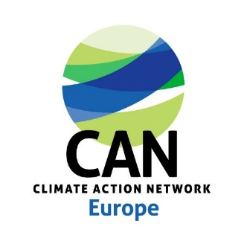 Terms of Reference (TORs)
Consultancy Support to accompany the set-up of CAN Europe management team including to help shaping the line-management approach of the secretariat

BACKGROUND
CAN Europe, Europe’s leading NGO coalition fighting dangerous climate change, has significantly grown these last three years and is now composed of nearly 60 staff members. Around 35 staff members are based in Belgium while the others are based in several countries spread all over Europe (England, Germany, Greece, North Macedonia, Poland, Portugal, Serbia, Spain, Sweden, Turkey,…). Moreover, last October 2021, a new director has been appointed by the Board, replacing the previous director who has been occupying the position for the last 10 years.
In order to ensure a smooth running and management of the CAN Europe’s Secretariat and Network (approx 180 members), it was decided last June 2022 to set-up a management team with the main objectives to 1) strengthen information sharing across departments and teams (internal communication); 2) improve collective strategising and implementation of activities; 3) guide prioritising and de-prioritising of objectives and worksteams,. This team is composed of the director, the deputy director, the head of Communication, the head of Network Development and the head of Operations. Note that a hiring process for a head of Climate team is ongoing. This newly created position is aimed to join the management team.
CAN Europe is now looking for an external consultant who will be requested to help the management team finalising its terms of reference, consolidate its functioning and to guide it on the team’s line-management approach, practices and tools in order to foster an enabling and inclusive environment for the whole team.

ACTIVITIES AND DELIVERABLES
Activity | Output | Timeframe
Activity 1: Meeting with each member of the management team, individually and collectively | Terms of reference of the management team | September-October 2022
Activity 2: Meeting with the entire team and/or advice and help preparing a conversation of the management team with the whole staff | Making sure the role of the management team is clarified and accepted by the whole team | September – October – November 2022
Activity 3: Analyse the organisation’s governance and propose some improvements regarding the line-management’s structure and method. Specific consultation with the HR coordinator to be included. | Final recommendations report and/or proposal for a plan of implementation | December 2022

TIMELINE & BUDGET
Budget foreseen: please send your proposed methodology together with your financial bid to Chiara Martinelli (chiara.martinelli@caneurope.org) by Wednesday 17 August the latest.
Start date: As soon as possible in September 2022
End date: End of the year 2022

LOGISTIC SUPPORT
This consultancy does not include any logistical support by CAN Europe. Though the CAN Europe team remains available to provide access to documents and information, where appropriated, and set-up meeting rooms and/or online meetings.

ADDITIONAL INFORMATION
For clarifications and queries: Chiara Martinelli chiara.martinelli@caneurope.org

