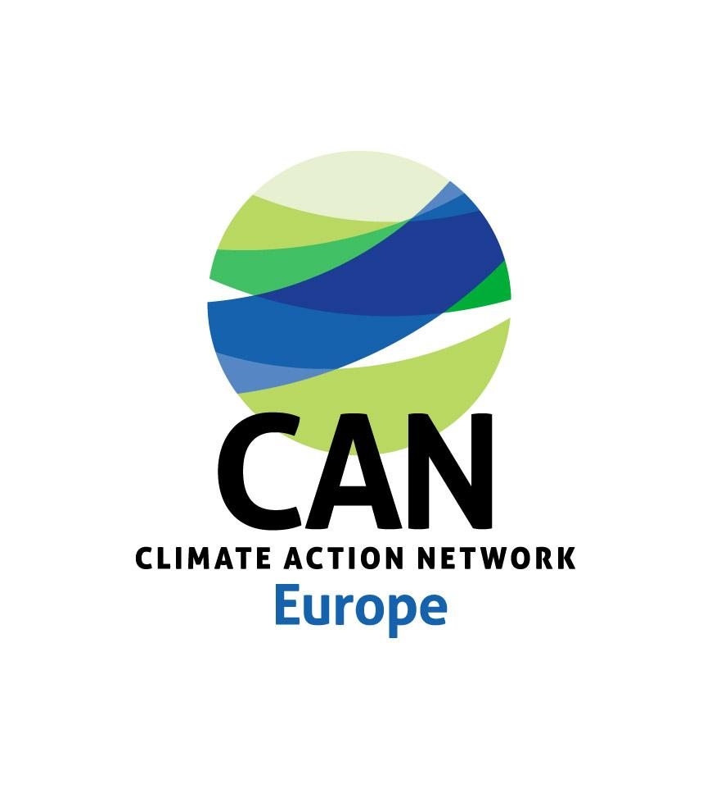

**Application form for   
Climate Action Network Europe Membership**

**Introduction**

Thank you very much for your interest in becoming a member of Climate Action Network Europe!   
We would like to get to know you better, so we ask that you fill in this form and use it to tell us about yourself. The questionnaire is designed to provide information on all the membership criteria CAN Europe takes into consideration and the answers should enable the current members of CAN Europe to judge your application accordingly - we hope you will find it easy enough to fill in. Wherever you feel that relevant additional information may be found in other material, please provide web links or send copies along.

**Please be so kind to send us your membership application together with the following information:**

* **Two reference letters from existing members (the Network Development Team will assist in the process if needed)**
* **Accounts (ideally from the last 2 years) translated into English**
* **Annual report of the previous year, together with a one page summary in English**
* **Copy of the Statutes or a similar legal registration document of your organisation**
* **Signed template statement (legal representative of the organisation) declaring to fulfil all the membership criteria and certifying having due diligence and ethical guidance in place to avoid conflicting relationship with polluting or human rights violating interests**

**If you have any queries please contact Joe Inwood, Network Development Coordinator joe.inwood@caneurope.org**

**Application by the organisation :** *Name*

**1. General Information**

This section is meant to provide basic data about origin and size of your organisation.

| 1.01 | **Choose Type of Membership - accepted or observer member\*** |  | | | | | | |  | | |
| --- | --- | --- | --- | --- | --- | --- | --- | --- | --- | --- | --- |
| 1.02 | **Name of your organisation** |  | | | | | | |  | | |
|  | **English Translation (where applicable)** |  | | | | | | |  | | |
|  | **Acronym of the Organisation (if different in English please put this between brackets)** |  | | | | | | |  | | |
| 1.03 | **Legal form** (please explain if other than non-profit)** |  | | | | | | |  | | |
| 1.04 | **Date of Establishment** |  | | | | | | |  | | |
| 1.05 | **Address of Organisation** |  | | | | | | |  | | |
| 1.06 | **Country** |  | | | | | | |  | | |
|  | **Telephone (including international code)** |  | | | | | | |  | | |
|  | **Website** |  | | | | | | |  | | |
|  | **General e-mail** |  | | | | | | |  | | |
| 1.07 | **Main contact persons on climate change and energy issues (who should we contact on which topics)** |  | | | | | | |  | | |
|  | **Email of the contact persons** |  | | | | | | |  | | |
|  | **Telephone number of contact persons** |  | | | | | | |  | | |
| 1.08 | **Working languages of the organisation** |  | | | | | | |  | | |
| 1.09 | **Is your organisation a network (of organisations)?** | □ YES | | | □ NO | | | | |  | |
|  | **If yes, can you give a link to your membership list** |  | | | | | | |  | | |
|  | **Does your organisation operate in more than one country? If yes, which ones?** |  | | | | | | |  | | |
|  | **In case your headquarters are not based in Europe, can you confirm you are already a member of the regional reference CAN node or CAN International? (if not, check with the CAN Europe secretariat before applying)** |  | | | | | | |  | | |
|  | **Direct Members of your organisation** | **Number of individuals** | |  | | **Number of organisations** |  | | |  | |
|  | **Indirect Members of your organisation (members of your member organisations, if applicable)** | **Number of individuals** | |  | | **Number of organisations** |  | | |  | |
| 1.10 | **Number of staff (full-time equivalent)** |  | | | | | | |  | | |
|  | **Number of volunteers** |  | | | | | | |  | | |
|  | **Number of staff working on climate change or energy issues** |  | | | | | | |  | | |

| 1.11 | **Briefly describe the governance structure of your organisation (eg. General Assembly/Board/...).** |  |
| --- | --- | --- |
| 1.12 | **Please provide a list of your Board members** |  |

* See Article 6 of our CAN Europe Statutes and explanation in the application pack.

** E.g. status of an organisation, such as vzw or asbl (Belgium), e.V. (Germany)

**2. Your Work – Aims and Activities of your organisation**

This section is meant to give an insight into the nature of your work and your link to energy and climate change issues and it asks about your links with governments and industry.

| 2.01 | **Briefly describe your organisation, how it works and its objectives (not just related to energy or climate change)** |  | | | | |  | |
| --- | --- | --- | --- | --- | --- | --- | --- | --- |
| 2.02 | **Please describe the work you are doing on energy and climate change related issues (if different from above)** |  | | | | |  | |
| 2.03 | **Do you have a specific target audience for your work? If yes, who?** |  | | | | |  | |
| 2.04 | **Is your organisation part of other networks that are member of CAN? If yes, which ones?** |  | | | | |  | |
| 22.05 | **For how long has your organisation been working on climate related issues? Please tick the appropriate.** | □ **Less than 2 years** | □ **For up to 3 years** | □ **For 3 to 5 years** | □ **For 6 years or longer** |  | | |
| 2.06 | **Do you confirm that you are an independent non-governmental organisation that is not linked to any government or any political party? Please note you will be asked to sign a statement on this** |  | | | | |  | |
| 2.07 | **Do you confirm that your organisation has enough safeguard mechanisms in place (in terms of due diligence and ethical screening) to avoid conflicting relationships with polluting, environmentally damaging, or human rights conflicting companies and entities as part of your activity, programs, campaigns, projects or funding? Please describe these mechanisms and note you will be asked to sign a statement on this.** |  | | | | |  | |
| 2.08 | **Do you confirm that board members or top management staff in your organisation do not have a conflict of interests with the above mentioned companies and entities? Please note you will be asked to sign a statement on this** |  | | | | |  | |
| 2.09 | **Does your organisation work together with other sectors of the industry? If yes, in which way? And can you indicate how you ensure independence from business interests, in particular when you have business people represented in your Board** |  | | | | |  | |

**3. Motivations for membership CAN Europe network**

We would like to learn more about your motivation for joining CAN Europe and your expectations and existing connections you may have with us already.

| 3.01 | | **Why does your organisation want to become a member of CAN Europe? What would be the benefits for you? And what would be the benefits for CAN Europe?** |  | |
| --- | --- | --- | --- | --- |
| 3.02 | **Do you already cooperate with other CAN members? Where and on what issues?** | |  | |
| 3.03 | **How do you expect to benefit from CAN Europe?** | |  | |

**4. Your Policy Positions**

This information is intended to give our members a better picture of your policy work and priority areas and how they fit with the variety of organisations in the network, as well as common positions taken by CAN Europe. A lack of information on work priorities and policy positions has in the past led to delays in deciding on membership applications, and we would like to avoid that going forward. If there is an issue listed below on which you do not have an explicit position formulated, you can state that also.

| 4.01 | **What are your three main work areas (related to climate change) and describe the main goal for them.** | 1. |  | |  | |
| --- | --- | --- | --- | --- | --- | --- |
| 2. |  | |  | |
| 3. |  | |  | |
| 4.02 | **CAN Europe's main direction is outlined in its** [**Vision and Strategy**](https://caneurope.org/can-europe-vision-and-strategy/)**\*. Can you confirm that the relevant people in your organisation have read the Vision and Strategy and agreed to it** |  | |  | | |

* You can find this here: [CAN Europe Vision and Strategy](https://caneurope.org/can-europe-vision-and-strategy/)

**5. Funding & Commercial Activities Information**

We would like to know the extent to which prospective members are politically independent, and for that reason we seek information on commercial activities, especially in cases where these may be linked to specific climate policy issues.

| 5.01 | **Briefly describe the nature of your organisation's funding sources, including approximate percentages.** |  | | | |  | | |
| --- | --- | --- | --- | --- | --- | --- | --- | --- |
| 5.02 | **Is your organisation engaged in activities generating emission reduction credits or in the selling of any type of emission credit? Please tick the appropriate box.** | □ YES |  | □ NO |  | |  | |
|  | **If yes, describe the nature of the activities and which quality criteria you are using, if any.**  **Which share of your income comes from these activities?** |  | | | |  | | |
| 5.03 | **Is your organisation involved in any other kind of commercial activity? Please tick the appropriate box.** | □ YES |  | □ NO |  | |  | |
|  | **If yes, briefly describe the nature and scope of those activities.** |  | | | |  | | |

**6. Membership Fees – Administrative Information**

This information will facilitate the work of our Finance Manager with regard to invoicing your organisation for the annual membership fee, once your application is approved. For more information on the membership fee structure, see Annex to the Application Package.

| 6.01 | **Estimate of the annual budget of your organisation on climate related work\*** | ***Budget*** | ***Corresponding CAN Europe Membership fee*** | ***Please tick appropriate*** | | |
| --- | --- | --- | --- | --- | --- | --- |
|  | * This refers to both staff costs and operational costs related to climate change, including work on transport, energy, climate & development or coordination by your organisation of projects/activities related to climate change. | Up to 50.000€ | 120€ |  | | |
| Up to 100.000€ | 230€ |  | | |
| Up to 250.000€ | 580€ |  | | |
| Up to 500.000€ | 1.150€ |  | | |
| Up to 1.000.000€ | 2.300€ |  | | |
| Over 1.000.000€ | 3.400€ |  | | |
| 6.02 | **Name of the person who should be receiving the membership fee invoice** |  | | |  | |
|  | **Phone number** |  | | |  | |
|  | **Email address** |  | | |  | |

**7. Additional Requirements**

The application process and criteria require additional information/commitment from any new applicant, in the form of letters of support and the consent to the core goals, practices and positions of CAN Europe - this section asks that it be made explicit.

| 7.01 | **How did you become interested in CAN Europe/ Where did you hear about the network?** |  | |  | | | |
| --- | --- | --- | --- | --- | --- | --- | --- |
| 7.02 | **Please name the organisations that you are receiving reference letters from.** | Reference organisation 1 | Reference organisation 2 | | | | |
| 7.03 | **By signing and submitting this form, you hereby subscribe to the following** | | | |  | | |
|  | **Vision and Mission of CAN Europe**  The vision of CAN Europe is a world actively fighting the climate emergency and its adverse impacts on people and planet in a manner that promotes equity and social justice.  CAN Europe’s mission is to empower civil society organisations to influence the design and implementation of effective policy in Europe through advocacy, mobilisation, and communications, to ensure Europe contributes its equitable share of global efforts to tackle the climate emergency. | | | |  | | |
|  | [**> CAN Europe statutes** *Read the statutes here****.***](https://caneurope.org/content/uploads/2016/06/Statutes-CAN-Europe-13-10-2017.pdf) | | | |  | | |
|  | [**> CAN International charter** *Read the charter here.*](https://climatenetwork.org/resource/can-charter/) | | | |  | | |
|  | **> Code of conduct**  The code of conduct within the network includes a) respecting the confidentiality of all content of communications and information stated at CAN meetings and in internal communication via email; b) support of existing CAN-Europe policy positions; c) refraining from public confrontation with other groups in the Network on their specific policy positions. | | | |  | | |

**I hereby confirm that this information is correct to the best of my knowledge.**

**Name, Date and Signature:**

***Thank you for your time !***